Press Release:

Tuesday 5th December | 6-10pm
DiscoMAKE

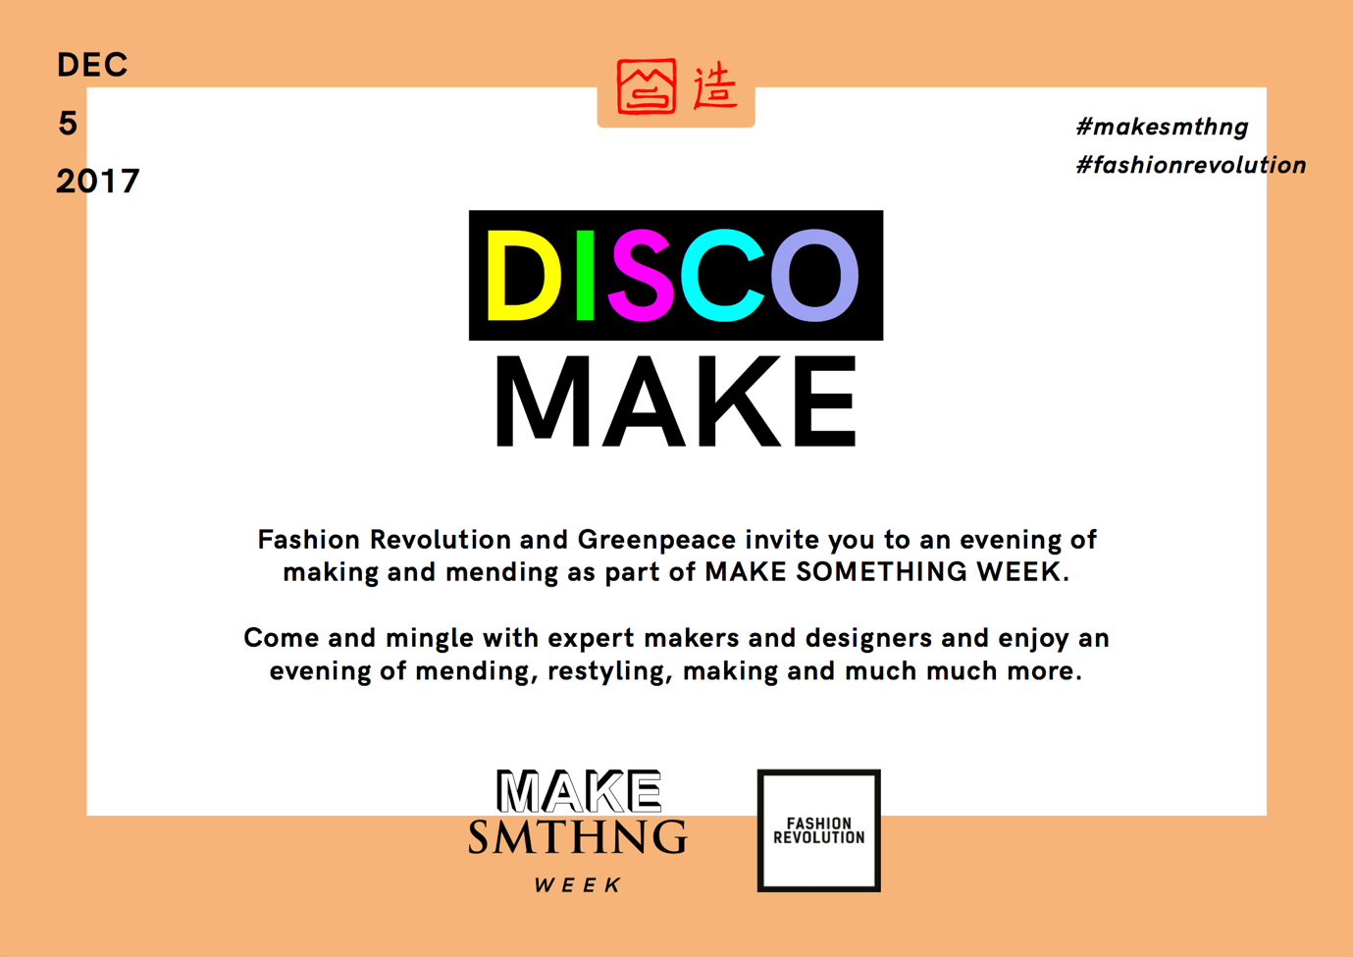

Mercato Metropolitano 42 Newington Causeway, London SE1 6DR

Fashion Revolution and Greenpeace are teaming up for Make Something Week, an initiative designed to encourage everyone to buy less and make more, which runs globally from the 2nd—10th of December, just after the hyper-consumption that will inevitably occur during Black Friday, Cyber Monday and Singles Day.

We are already producing over 100 billion garments of clothing each year (with up to 40% of them remaining unworn, discarded and unloved). Isn’t it time we start falling in love with the stuff we already own?

Join us for an evening of “disco making”; have your broken clothes mended and customised by expert makers and young designers, come and knit, patch, restyle and overall play with us as we commit to creative ways to making our clothes last longer. Located at the beautiful Mercato Metropolitano, DiscoMAKE will gather together a group of makers, designers and influencers mending, sharing, swapping, transforming, repairing and creating.

However, DiscoMAKE is not a series of workshops, but more a place to experience and watch things being made, or have your clothes repaired, in a playful, creative environment.

Here are some of our planned activities:

Care Repair Rewear a practical, symbolic, aesthetic, original, creative, trendsetting, globetrotting, badass, revolutionary way to say my clothes are me, my chosen skin, my principles, my story. Long live my clothes.

Dress Undress Redress As long as there are clothes being made, there will be off- cuts, and as long as will be wearing clothes, we will leave a trail of our unwanted pieces. Challenge your inner textile chameleon and design your fleeting costume from wonderful waste.

Floordrobe Stylist A real life “paper doll” scenario that will inspire guests to create outfits on the floor and see how old clothes can look as cool as than new clothes.

Darn It Stitch, cross stitch, back stitch, thread, pin, patch, iron, cover, uncover, embroider, add beads, mend a seem, needlework, patchwork, re- hem, reshape, customise, improvise, transform, reborn, reconstructed, deconstructed, bespoke, cut short, made longer, tailor made, remade, saved. Loved clothes last.

D.I.Y. stress your denim
Tear or mend? New or old? Ripped or stitched?
The only way is up (cycled)!

Our guests will include designers such as Michelle Lowe Holder, Katie Jones and Bethany Williams; experienced makers and campaigners Craftivists and By Hand London

A special Thank you to Mercato Metropolitano for hosting the event, Traid and Barnardo’s for donating all second hand garments involved in the action, Wool And The Gang for donating their wools.

This @makesmthng week is all about taking action for a better world — instead of buying we want to MAKE something.
#makesmthng
#fashionrevolution

Contact:
Orsola@fashionrevolution.org

