Press Release
9th October 2017
Fashion Revolution launches pre-orders of its bumper fanzine Issue #002: Loved Clothes Last
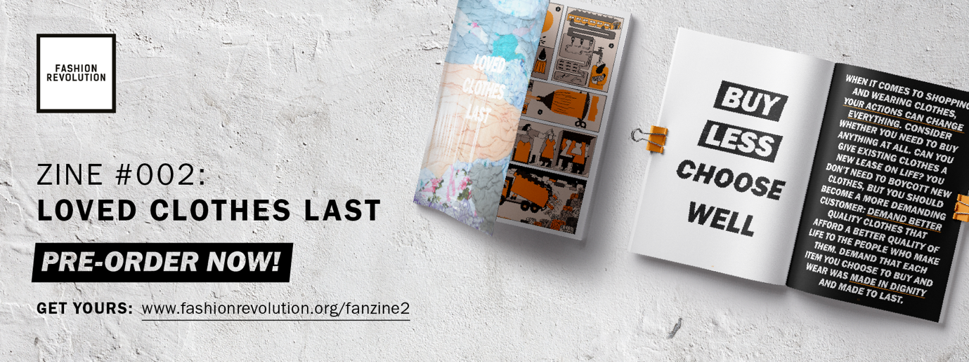
Issue #002: Pre-orders will be available at www.fashionrevolution.org/fanzine2 for £15 + £5 p&p and will be sent out in the first week of November. Review copies available for journalists upon request.
Today, Monday 9th October 2017, Fashion Revolution is launching pre-orders for the second in a series of its bi-annual collectible fanzines which seek to uncover the stories behind the clothing we wear.
#lovedclotheslast explores the issue of waste and mass-consumption in the fashion industry, and hopes to inspire you to buy less, care more, and know how to make the clothes you love last for longer.
A big, double-edition issue — with 124 pages of poetry, illustration, photography, infographics, it’s packed with articles, tips and interviews with leaders of the circular fashion movement and innovators in textile recycling.
With over 80 contributors, including artists Tyler Spangler, Ged Palmer, William Farr, poet Hollie McNish, and illustrators Rob Phillips, and Celeste Mountjoy, and 17-year-old fashion blogger Tolly Dolly Posh plus experts such as Rebecca Earley, Elizabeth L. Cline, Christina Dean, Kate Fletcher, Lewis Perkins, Greenpeace and Cyndi Rhoades, plus many submissions from the Fashion Revolution community around the world.
The fanzine will take readers on a journey to identify and understand the problems in the industry whilst discovering the innovators, the designers, and the organisations that are doing something about it already, to finding your own way to a zero waste path.

Clothing production has more than doubled since 2000 and yet we don’t use 40% of the clothes we buy. The cycle of accelerated growth in mass production and consumption of fashion is putting undue strain on our resources, at both ends. The lack of transparency in the fashion supply chain prevents us from seeing exactly how much, and where waste occurs.

Orsola de Castro, co-founder of Fashion Revolution said: “We need to stop seeing our clothes as disposable. Our ready-to-wear is becoming a ready-to-throw. If only we all knew how much time and energy goes into making our clothes, we might slow down this unhealthy cycle of buying endlessly and, at times, needlessly. We need to find ways to break free from our addiction, reverse the throwaway culture and discover new ways to love our clothes. Far from being a part of the problem, we can all, enthusiastically and creatively, become a part of the solution.”
-Ends-
For more information, images or interviews, please contact Martine Parry martine.parry@fairtrade.org.uk 020 7440 7695 / 07886 301 486.
Notes to editors
About Fashion Revolution:
Fashion Revolution is a global movement that works for a more sustainable fashion industry, campaigning for a systemic reform of the industry with a special focus on the need for greater transparency in the fashion supply chain. Fashion Revolution is a non-profit organisation with presence in more than 90 countries around the world. Our vision is a fashion industry that values people, the environment, profit and creativity in equal measure. Fashion Revolution works all year round to raise awareness of the fashion industry’s most pressing issues, advocate for positive change, and celebrate those who are on a journey to create a more ethical and sustainable future for fashion.
The proceeds of this non-profit zine will go towards creating more inspiring and informative resources like this zine in the future and helping to grow the Fashion Revolution movement.
This limited edition fanzine began with Fashion Revolution reaching out through their social media channels to the public and their inspiring community of 'Fashion Revolutionaries’ across the world for creative submissions. The social media movement has also collaborated with some exciting artists and writers to create the incredible content for this publication.
Social media info:
www.instagram.com/fash_rev/
www.facebook.com/fashionrevolution
www.twitter.com/fash_rev
Hashtags:
#fashionrevolution
#lovedclotheslast
Fashion facts and stats
- Global clothing production more than doubled since 2000, exceeding 100 billion garments produced in 2014. [Source McKinsey]
- The average person buys 60% more clothing and keeps the for about half as long as 15 years ago. [Source McKinsey]
- An estimated £140 million worth (350,000 tonnes) of clothing goes to landfill in the UK every year. [Source WRAP]
- In USA, 10.5 million tons of clothing is sent to landfill every year. That’s about 30 times as heavy as the empire state building. [Source: Elizabeth Cline]
- It is estimated that we make 400 billion m² of textiles annually. 60 billion m² is cutting room floor waste. [source Gugnami & Mishra]
You can read more about Fashion Revolution at fashionrevolution.org.

