PRESS RELEASE
Fashion Revolution ‘Loved Clothes Last’
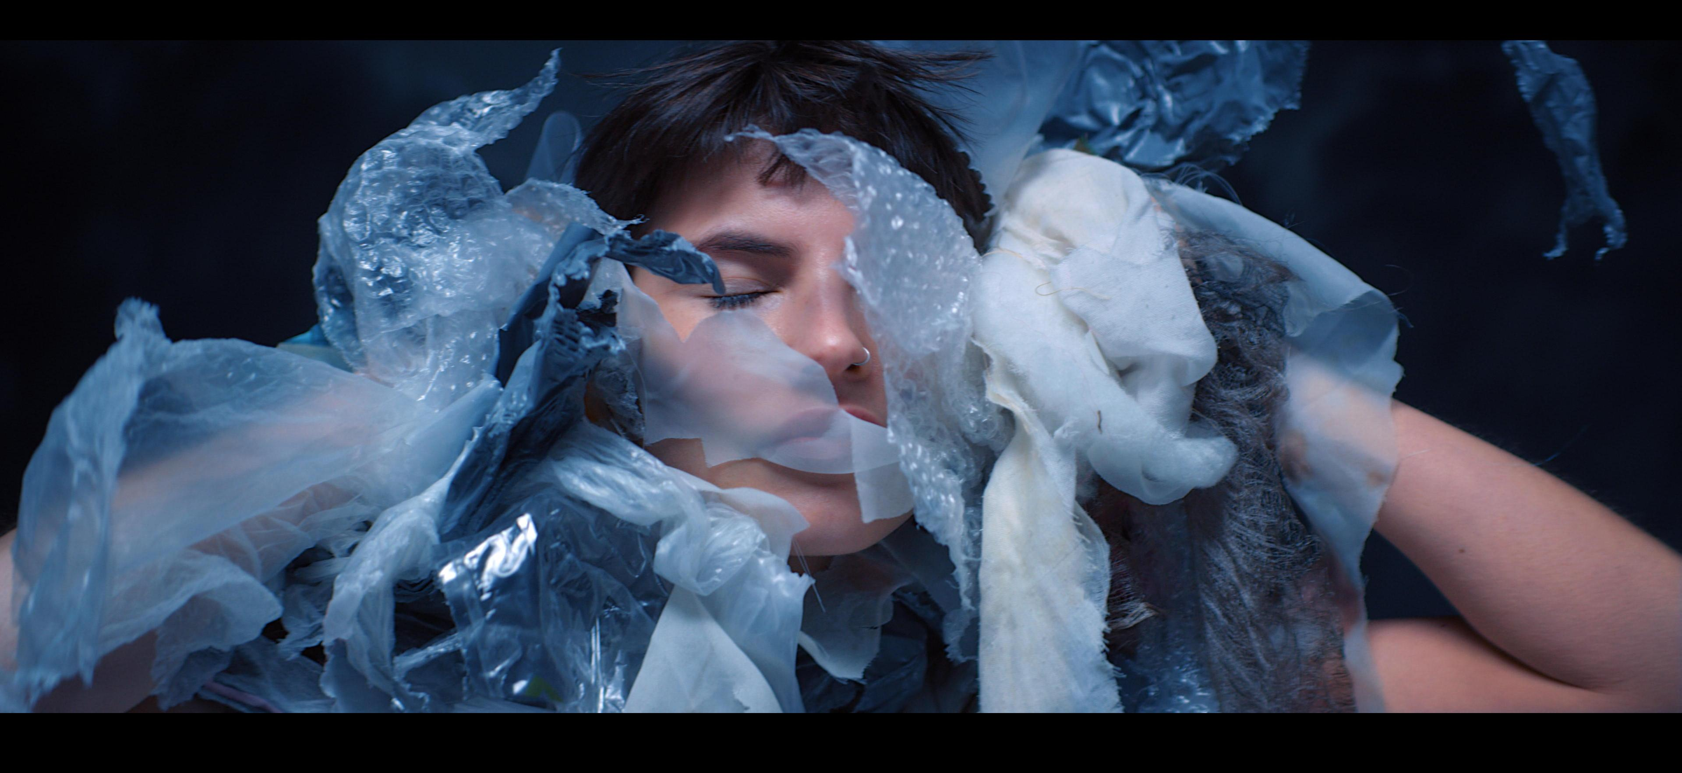
https://youtu.be/4zXQWrcTKgs
This April, Fashion Revolution will launch a short film " Loved Clothes Last " to comment on the issue of mass consumption and waste, which has created an unprecedented crisis and a significant impact on climate change.
The film was directed by Balthazar Klarwein and produced by production company Feel Films. Starring Angelina Jesson, it showcases a disturbing dystopian reality where landfill and decay meet everyday life, the result of decades of mindless overproduction and accelerated consumption and wonders when will we slow down and accept a future where we all understand the importance of loving, and keeping, our clothes for longer.
Focusing on a series of symbols (from Wabi Sabi to rebirthing and circularity) the film explores mindfulness, consciousness and, with its final call to arms #LovedClothesLast, it encourages viewers to understand how small actions can benefit the planet, reduce landfill mass and ultimately create a more meaningful relationship with the things we choose to buy.
In the words of director Balthazar Klarwein, “Never has a fashion shoot felt so good.”
Feel Films producer, Bona Orakwue adds, “It’s been such an honour to collaborate with Fashion Revolution, whose work is so innovative and so important. I couldn’t be prouder of what we’ve achieved together on this extraordinary project.”
Founder and creative director of Fashion Revolution, Orsola de Castro explains, “This is the first time that Fashion Revolution combines campaigning for supply chain transparency with a new dedicated focus on environmental issues. The film therefore marks the start of a new journey, #whomademyclothes to #lovedclotheslast - looking at the full story from the origins of the clothes we buy to their end of life.”
The film was post produced by creative content studio, The Mill. Mill lead artist, Gareth Brannan comments, “It's a real privilege to be a part of such a beautiful project to help promote a conversation which is long overdue.”
The film is partly sponsored by Electrolux and takes inspiration from the AEG/NJAL Care Label Project, which Fashion Revolution is supporting.
Special thanks to Feel Films and The Mill, without their partnership and support this film would not have been possible, Thank you.

About Fashion Revolution
Fashion Revolution is a global movement calling for greater transparency, sustainability and ethics in the fashion industry. The non-profit organisation aims to unite the fashion industry and ignite a revolution to radically change the way our clothes are sourced, produced and purchased, so that what the world wears is made in a safe, clean and fair way. During this year’s Fashion Revolution Week 24-30th April, Fashion Revolution encourages people to ask brands #whomademyclothes and to question where their clothes come from.
Fashion Facts :
● Global clothing production more than doubled since 2000, exceeding 100 billion garments produced in 2014 (source McKinsey )
● The average person buys 60 percent more items of clothing and keeps them for about half as long as 15 years ago. About 40% of the clothes are rarely or never worn. (source McKinsey )
● In USA, 10.5 million tons of clothing is sent to landfills every year (source Cline 2014)
● 95% of the clothes sent to landfills could have been recycled or upcycled (source Current Status of Fiber Waste Recycling and its Future )
● By doubling the useful life of clothing from one year to two years reduces emissions over the year by 24% (source Carbon Trust )
For the full list of events happening during Fashion Revolution Week around the world,
visit www.fashionrevolution.org/events
For more information please contact roxy@fashionrevolution.org

Credits List
Production
PRODUCTION COMPANY - Feel Films
BALTHAZAR KLARWEIN – Director
BONA ORAKWUE - Producer
HIYWET ABATE - Production Manager
GARETH WRIGHTON - Creative Director
JERRY BLAND - Art Director
ROBERT SANDERS - Costume designer
GARETH WRIGHTON & JACK APPLEYARD - Props Designer
ANTHONY NEALE & EMMA STEELE - Assistants to Art Director
JAY SALOMON - First Assistant Director
EDWARD GIBBS - D.O.P. @ W.P.A.
DANIEL LOBO PIRES - Camera Operator & Equipment
JASON CUDDY - Focus Puller
GEORGE TELLING - Camera Assistant
NATASHA CREAMER - Camera Trainee
DAVE & ANDY MCNAULTY – Grip & Equipment
NICK KENEALY - Video Playback Operator & Equipment
MALCOLM GREENHILL - D.I.T. & Equipment
ELERI SHONE - Runner
MARK ALVERES - Gaffer
JOSH WOOD - Electrician
SIMON INGRAM - Electrician

ANGELINA JESSON - Lead Actor & Model @ Premier Model Management
LILIAN KOMOR - Make-up & Hair Designer
MARK JOYCE - Medic
STEVE GIUDICI & PAULINE FENNER - Island Studios

Editing
EMANUELE CRIVELLARI - Editor
JENNY KARAKAYA & MARYAM FAIZ - Archive Footage @ Shutterstock

Sound
TOBY JARVIS & ROB DURHAM - A-Mnemonic Music
NICK ANGELL & DAVE ROBINSON - Angell Sound

VFX and Design - The Mill
NICOLE DUNCAN - Producer
OISIN O'DRISCOLL - Colourist
GARETH BRANNAN - Lead 2D Artist
GEORGE ROCKLIFFE - 2D Artist

Equipment
MATT BOUNSALL @ TAKE 2 FILMS - Camera Equipment
GRAHAM ANGUS @ PANALUX - Lighting Equipment
VINCENT SHAW @ METRO RIGGING - Rigging Equipment
PAUL MANN @ MACHINE SHOP - Special Effects
STEPHANIE BLESS @ FERAL - Easy Rig
STOCKYARD - Backdrops

Fashion Revolution:
Orsola de Castro – Founder & Creative Director - Fashion Revolution
Carry Somers - Founder & Global Operations Director - Fashion Revolution
Heather Knight – Head of Comms - Fashion Revolution
Roxanne Houshmand-Howell Head – Head of Brands & Partnerships – Fashion Revolution
Sarah Ditty – Head of Policy - Fashion Revolution
Valerie Kittlitz - Executive Assistant - Fashion Revolution

Sponsorship
ELECTROLUX, AEG, GREENPEACE

Clothing Donations
Maria Chenoweth
Leigh McLea
Brandy Easter at Traid

Social Handles
When posting on social channels, please use the below handles to credit associated companies

Copy to use for social:
Inspiring us all to need less and love forever, Fashion Revolution’s short film looks at mass production, consumerism and the tragedy of modern-day landfills, to remind us that small individual actions can have a lasting effect #LovedClothesLast Directed by `@balthazarklarwein, produced by @feelfilms, and starring @angelinajesson @fash_rev

Hashtag:
#LovedClothesLast
#FashionRevolution

Many thanks to: SOCIAL HANDLES FOR ALL MAIN COMPANIES INVOLVED. SEE BEOW FOR @...

Fashion Revolution
Facebook:.facebook.com/fashionrevolution.org/
Instagram: fash_rev
Twitter: @Fash_Rev

Feel Films
Facebook: facebook.com/Feel-Films
Instagram:
Twitter: @feelfilms
Electrolux
Facebook: @electroluxuk
Instagram: @electrolux
Twitter: @electrolux
The Mill
Facebook: facebook.com/millchannel
Instagram: @millchannel
Twitter: @millchannel
Greenpeace
Facebook: @greenpeace.international
Instagram: @greenpeace
Twitter: @greenpeace
Traid
Facebook: @TRAIDcharity
Instagram: @traid
Twitter: @traid
Premier
Facebook: @PremierModelManagement
Instagram: @premiermodels
Twitter: @premiermodels
Take 2
Facebook: @Take-2-Films-769078673127907/
Instagram:
Twitter: @Take2FilmsUK
Island Studios
Facebook: @Dukes-Island-Studios-111873265540465/
Instagram:
Twitter: @IslandStudios1
Worldwide Production Agency
Facebook: @WPAgency
Instagram: @wpagency
Twitter: @wpagency

Angell Sound
Facebook: @AngellSound
Instagram: @angellsounduk
Twitter: @angellsounduk
A-Mnemonic Music
Facebook: @amnemonic
Instagram:
Twitter: @a_mnemonic
Shutterstock
Facebook: @Shutterstock
Instagram: @shutterstock
Twitter: @Shutterstock
Panalux
Facebook: @panaluxworldwide
Instagram: @panaluxworld
Twitter: @panaluxworld

