Fashion Revolution 2017
#Haulternative

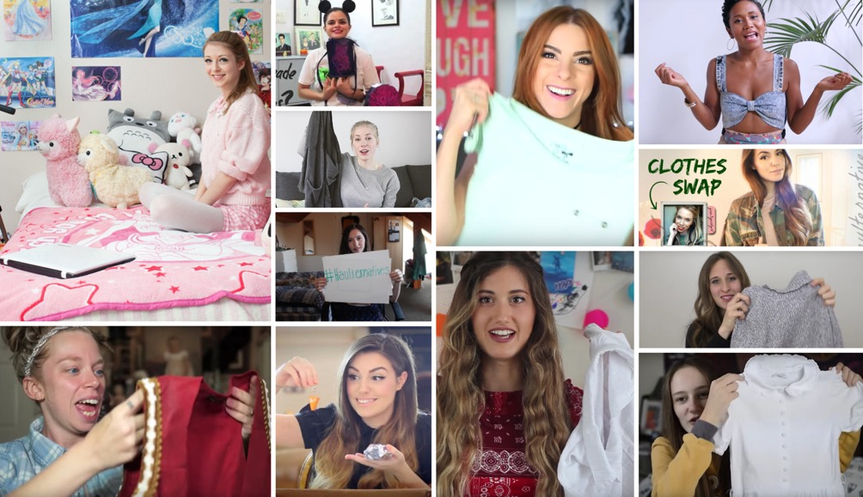

Fashion Revolution Week 24-30th April 2017 marks the third consecutive year of the #haulternative initiative, where global influencers are asked to create a different type of YouTube "haul" that doesn't involve buying new clothes, but instead explores sustainable ways to enjoy previously owned pieces by customising, swapping, buying second hand or mending.

There are 9 #haulternative challenges to choose from: Love Story, Broken & Beautiful, Fashion Fix, 2Hand, Swap, DIY, Vintage, Hire and Slow.

Download the Haulternative Guide

Top influencers such as CutiePieMarzia, Maddu, Noodlerella and Grav3yardgirl have taken part in previous years, generating over 4 million views on YouTube. Their participation has also inspired the idea to spread, with hundreds of fans taking part and filming their own version of a #haulternative. This year the initiative will grow to see more influencers join and new layers added, such as a series of 'hack films' sponsored by Avery Dennison and "love story" videos in collaboration with Vivienne Westwood.

The 2017 #haulternative initiative will include popular social influencers from the UK, US, Brazil and Germany. Top influencers CutiePieMarzia and LaMadelyn will do a clothes swap. In the UK,
Hannah Witton will do a Fashion Fix; Kelsey Ellison and Beckii will shop from vintage and thrift. In Germany My Green Closet will be sharing her audience’s love stories. In Brazil Marieli Mallmann will do a whole week of social posts inspired by the initiative, and Bonita Fica Dica & Nunca Te Pedi Nada will also participate.

Vivienne Westwood will also take part this year by creating a series of Love Story videos engaging supporters and admirers who are committed to keeping and caring for their Westwood pieces and Avery Dennison has donated Fashion Revolution branded patches (made with 90% recycled yarns) which will be gifted to influencers to mend their much loved but broken garments and give them a new lease of life.

YouTuber Cutie Pie Marzia said "Fashion Revolution brought up topics I was never aware of and pushed me to learn more about the fashion industry. It truly changed my mindset, and I am truly grateful for that, because now I can make better choices while sharing the things I've come to know with lots of people. I am positive that, all together, we can make a difference".

The #haulternative initiative was created in partnership with Lilly Ladjevardi, Director of Talent at Maker Studios.

Notes to Editors

Fashion Revolution is a global movement that works for a more sustainable fashion industry, campaigning for a systemic reform of the industry with a special focus on the need for greater transparency in the fashion supply chain. Fashion Revolution is a non-profit organisation with presence in more than 90 countries around the world. Our vision is a fashion industry that values people, the environment, profit and creativity in equal measure. Fashion Revolution works all year round to raise awareness of the fashion industry’s most pressing issues, advocate for positive change, and celebrate those who are on a journey to create a more ethical and sustainable future for fashion.
http://fashionrevolution.org/

Despite some steps forward since the Rana Plaza garment factory collapsed in 2013 killing 1134 people, not enough has changed. About 75 million people work directly in the fashion and textiles industry, and about 80% of them are women. Many are subject to exploitation, verbal and physical abuse, working in unsafe conditions, with very little pay. This is why the ‘who made my clothes’ question is still hugely important.

Fashion Facts
- Global clothing production more than doubled since 2000, exceeding 100 billion garments produced in 2014 (source McKinsey)
- The average person buys 60 percent more items of clothing and keeps them for about half as long as 15 years ago. About 40% of the clothes are rarely or never worn. (source McKinsey)
- In USA,10.5 million tons of clothing is sent to landfill every year (source Cline 2014)
- 95% of the clothes sent to landfill could have been recycled or upcycled (source Current Status of Fiber Waste Recycling and its Future)
- By doubling the useful life of clothing from one year to two years reduces emissions over the year by 24% (source Carbon Trust)

