Press enquiries contact press@fashionrevolution.org 020 7440 7695

FASHION REVOLUTION WEEK
18-24th 2016
#whomademyclothes

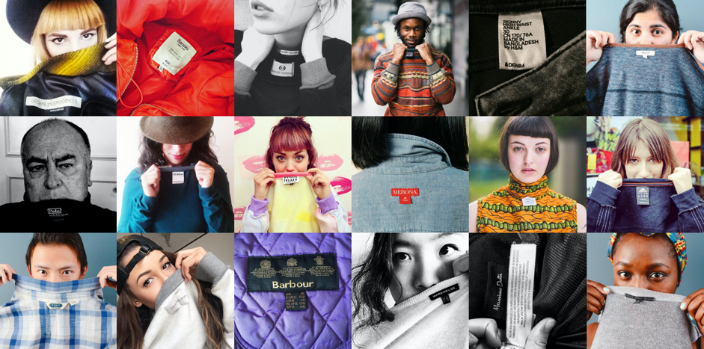

Fashion Revolution is back for a third year, calling for greater transparency in the global fashion supply chain and celebrating those on a journey to create a more ethical and sustainable future for fashion.

Celebrity supporters and fashion lovers in 86 countries around the world are being asked to show their support with a ‘label selfie’ to ask brands #whomademyclothes across social media during Fashion Revolution Week (18 – 24th April). Following the success of the inaugural Fashion Revolution Day in 2014, models Cameron Russell and Amber Valetta, Mariah Idrissi, Eco Age founder Livia Firth and bloggers Susie Lau, Gregory Davalos, Jenny Ong and Rachel Nguyen are just some of the names expected to take part in this year’s campaign. Leading up to 24 April, we are asking people to:

- Show your clothing label. You could turn your clothes inside out to make more of a statement.
- Follow that brand on social media with this message: “I want to thank the people who made my clothes, @brand #whomademyclothes?”

In a week-long series of activities and events, supporters around the world will challenge global fashion brands to demonstrate commitment to transparency across the length of the value chain, from farmers to factory workers, brands to buyers and consumers.

Events include:
- Fashion Question Time, Houses of Parliament, Westminster, hosted and chaired by Mary Creagh MP
- Launch of Fashion Revolution’s Transparency Index
- ‘The Upcycle Project’, which will will bring together the next generation of fashion designers in a 2 day upcycling workshop, with a private view and auction
- Flux: Fair Luxury Conference, Goldsmiths’ Centre
- Late Night Charity Shopping & Fundraiser with TRAID
- Three Fashion Revolution events as part of Utopia at Somerset House

For more information on local events, visit http://fashionrevolution.org/events/

Latest news:
#haulternative
YouTube ‘haulers’ get ethical with #haulternative campaign for Fashion Revolution Week. High street fast fashion shopping ‘hauls’ are a YouTube phenomenon. But some voguish celebrity vloggers with a conscience are finding alternative ways to get their fashion fix - refreshing their wardrobe without buying new clothes, from upcycling to swaps, to finding gems in charity shops. Building on two million views achieved in 2015 by YouTube vloggers including Noodlerella, Grav3yardgirl, CutiePieMarzia and Bip Ling, #haulternative will add ‘love story’, ‘broken and beautiful’ and ‘fashion fix’ to the collection for Fashion Revolution Week.

The Child Labour Experiment
Millions of children work in the textile supply chains worldwide. Fashion Revolution says enough is enough. As part of a social experiment, Fashion Revolution used hidden cameras to secretly film how the industry reacted to child workers.
https://youtu.be/8gA97UjCOUI

According to the ILO (International Labour Organization) more than 170 million children are engaged in child labour around the world, many working for the garment and textiles industry. Transparency is the first step to transforming this industry. Share this video, and ask #whomademyclothes to fight child labour.

Like Fashion Revolution on Facebook at facebook.com/fashionrevolution.org and follow @Fash_Rev
On Twitter and Instagram.

--‐ENDS--‐
For more information, images, interviews and footage, contact: press@fashionrevolution.org 020 7440 7695.

Notes to Editors
About Fashion Revolution:
Fashion Revolution is composed of key figures from the fashion industry and beyond: industry leaders; press; campaigners; consultants; representatives from charities and campaign organisations: academics and more with country co-ordinators in 86 countries around the world. We believe in fashion as an industry which values people, the environment, creativity and profits in equal measure and it’s everyone’s responsibility to ensure that this happens. Our mission is to bring everyone together to make that happen. On 24th April each year, Fashion Revolution will bring everyone in the fashion value chain together and help to raise awareness of the true cost of fashion, show the world that change is possible, and celebrate all those involved in creating a more sustainable future. As a global movement uniting around an annual campaign, over the next five years we plan to build considerable momentum and achieve incredible impact together. We recognize that, in many cases, Fashion Revolution will bring together organisations and people that, outside of Fashion Revolution Day, remain competitors.
- Fashion Revolution participated in high level EU, G7, UN and COP21 events last year and co-organised events at the European Parliament, UK House of Commons, UK House of Lords and beyond.
- Fashion Revolution will collaborate as a key stakeholder in the European Commission’s Garment Initiative in Spring 2016.
- In 2015, #whomademyclothes had 63 million reach and 124 million potential impacts on 24 April and we trended worldwide on Twitter on the day.
- 'The 2 Euro T-shirt: a Social Experiment' video went viral and has accumulated over 7 Million views to date. In June the video won the Bronze prize at the Cannes Lion Film Festival and this achievement was widely reported by international press, social media, with vlogger activity #Haulternative having achieved over 2 million views last year.

